Fundamentals of Data Science - Assignment 3 Report

Program 1: Read CSV File
Reads records.csv and displays student details like name, roll, program, year, and group.
Sample Output:
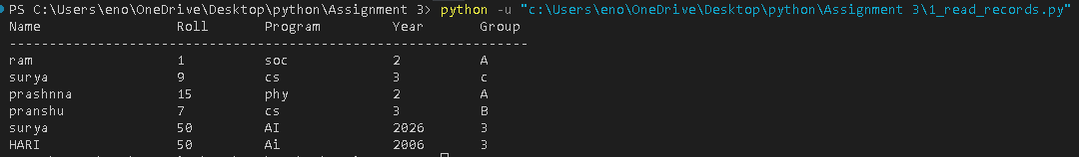

Program 2: Append to CSV
Takes user input and adds new student records into records.csv.
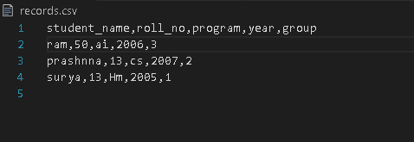
Sample Output:
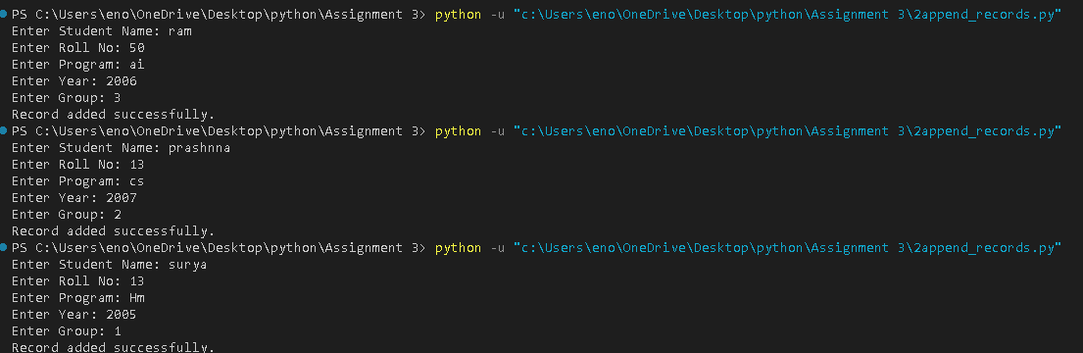

Program 3: Calculator with File Save
Performs arithmetic operations on user input and saves results with date and time.
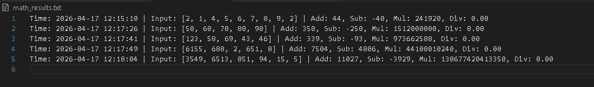
Sample Output:
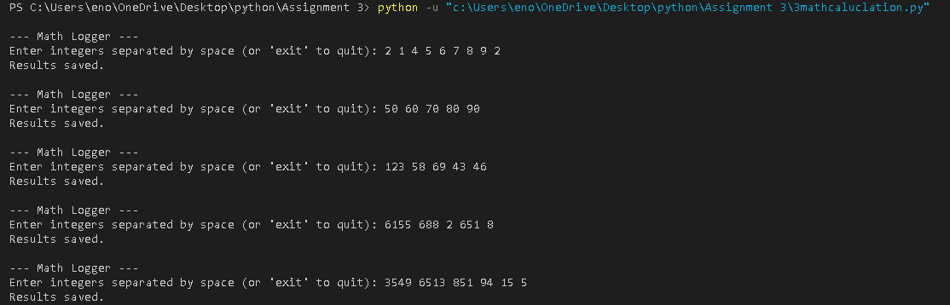

Program 4: File Copy
Copies content from one file to another using exception handling.
Sample Output:
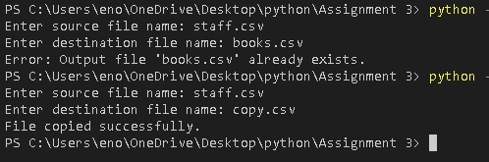

Program 5: Learner Class
Creates a Learner class, takes input, and displays learner details.
Sample Output:
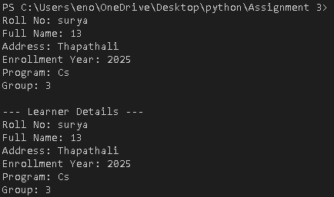

Program 6: Dish and Cookbook
Manages dishes using classes and stores recipe details.
Sample Output:
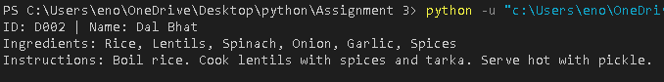

Program 7: Staff Management
Stores staff data into staff.csv and allows viewing records with exception handling.
Sample Output:
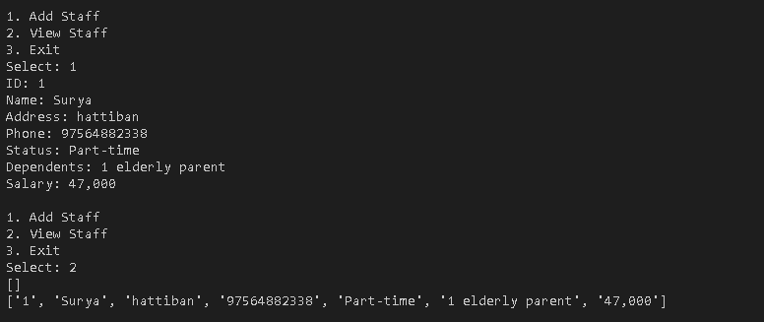

Program 8: Library Management System
Implements a basic library system with borrow, return, and search features using OOP.
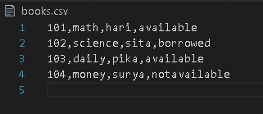
Sample Output:
